USAGE AND MAINTENANCE MANUAL

ELE

GAS BOILING PANS
- GKT7080
- GKT90100
- GKT90150
- GKT90250
- GKTD90150
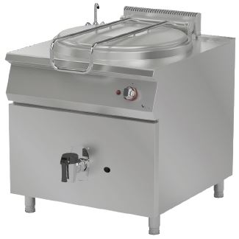
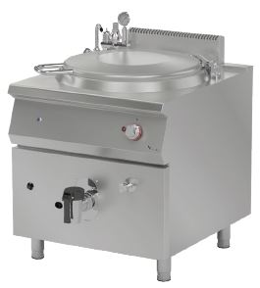
- GKTD90250

PRESENTATION

DEAR CUSTOMERS,
- To get the best yield of our products that are in compliance with the International Standards, we highly recommend you to read the user’s manual and have it read to your users for long and continuous usages.
- This manual contains important informations about the secure installation, usage and maintenance of the product and necessary remarks to make the most efficient usage of your device.
- Keep this manual in an easily accessible and safe place to use when necessary.
- Our product is designed for heating and cooking food commodities. Any chemical or liquid substances or similar that can be in contact with the foodstuff, cannot be used for any heat treating that can cause damages for the health.
- The manufacturer cannot be held responsible for any damages from incorrect usage of the device, to people, the environment, or other materials resulting from translation or printing of this booklet.

INDEX

PRESENTATION 2
INDEX 3
SAFETY DETAILS 3
TECHNICAL SPECIFICATIONS 4
TRANSPORTATION, PLACEMENT AND READY TO INSTALL 7
GAS CONNECTION 8
WATER CONNECTION 11
USAGE 12
1-) Switching On 13
2-) Switching Off 14
CLEANING 14
MAINTENANCE AND MALFUNCTION 14
Problems and Solutions 14
WARRANTY CONDITIONS 15
Out of Warranty Cases 16
AUTHORIZED SERVICE START-UP PAGE 17
Start Up Page 17

SAFETY DETAILS
- Do not expose the device to direct sunlight.
- Any kind of flammable or ignitiable solid or liquid such as alchocol and derivaritves, petro-chemical products, wood-plastic materials, curtains, clothes, etc. should not be kept in the area of the device.
- This device must be installed in accordance with the current regulations and should only be used in a well-ventilated area.
- The instructions should be analysed before the installation and the usage of the device.
- The device is designed for professional usage and should only be used by trained personnel.
- It should not be interfered without the presence of the manufacturer or the authorized service.
- The device or its components cannot be used for any other purpose.
- Apart from the heating and the cooking of the food, it cannot be used as a heater for any purpose.
- The device cannot be left uncontrolled as long as it is on.
- Food compatible gloves must be used to protect hands from the overheating.
- In case of fire or flame in the area where the device is, switch off the safety net which is located in the main circuit connection and then use the fire extinguisher. Water should absolutely not be used, otherwise the flame will sprawl faster.
- The installation and the maintenance should be carried out by the qualified staff autorized by the manufacturer. Serious danger for the user can be arise due to incorrect installations, maintenances or repairs, and the manufacturer cannot be held responsible.

technıcal specıfıcatıons
PRODUCT CODE |  |  |  |  |  | GKT7080 | GKT90100 | GKT90150 | GKT90250 | GKTD90150 | GKTD90250
DIMENSIONS  (mm) |  | A | WIDTH |  |  | 800 | 800 | 800 | 950 | 800 | 950
 |  | B | DEPTH |  |  | 730 | 900 | 900 | 1000 | 900 | 1000
 |  | C | HEIGHT |  |  | 850 | 850 | 850 | 950 | 850 | 950
GAS CONNECTION |  |  |  | G-20 (NG) |  | 1/2” | 1/2” | 1/2” | 1/2” | 3/4” | 3/4”
 |  |  |  | G-30 (LPG) |  | 1/2” | 1/2” | 1/2” | 1/2” | 3/4” | 3/4”
GAS CONSUMPTION |  |  |  | G-20 (NG) | MAXIMUM | 1,905m³/h | 2,540m³/h | 2,540m³/h | 3,810m³/h | 1,905m³/h | 2,963m³/h
 |  |  |  |  | MINIMUM | 1,000m³/h | 1,334m³/h | 1,334m³/h | 2,000m³/h | 1,000m³/h | 1,556m³/h
 |  |  |  | G-30 (LPG) | MAXIMUM | 1,420kg/h | 1,893kg/h | 1,893kg/h | 2,839kg/h | 1,420kg/h | 2,208m³/h
 |  |  |  |  | MINIMUM | 0,745kg/h | 0,994kg/h | 0,994kg/h | 1,491kg/h | 0,745kg/h | 1,159m³/h
COUNTRY | AL, BG, CY, CZ, DK, EE, FI, GR, HR, IT, LT, LV, MK, NO, RO, SE, SK, SI, TR | GAS PRESSURE |  | NOMINAL | G-20 (NG) | 20 mbar | 20 mbar | 20 mbar | 20 mbar | 20 mbar | 20 mbar
 |  |  |  |  | G-30 (LPG) | 30 mbar | 30 mbar | 30 mbar | 30 mbar | 30 mbar | 30 mbar
 |  |  |  | MAXIMUM | G-20 (NG) | 25 mbar | 25 mbar | 25 mbar | 25 mbar | 25 mbar | 25 mbar
 |  |  |  |  | G-30 (LPG) | 35 mbar | 35 mbar | 35 mbar | 35 mbar | 35 mbar | 35 mbar
 |  |  |  | MINIMUM | G-20 (NG) | 17 mbar | 17 mbar | 17 mbar | 17 mbar | 17 mbar | 17 mbar
 |  |  |  |  | G-30 (LPG) | 25 mbar | 25 mbar | 25 mbar | 25 mbar | 25 mbar | 25 mbar
 |  | INJECTOR |  |  | G-20 (NG) | mm | 2 mm | 2 mm | mm | 2 mm | mm
 |  |  |  |  | G-30 (LPG) | mm | 1,2 mm | 1,2 mm | mm | 1,2 mm | mm
GAS CATEGORY |  |  |  |  | II_{2H3B/P}
TOTAL HEAT CAPACITY (∑Q_{N}) |  |  |  |  |  | 18 kW | 24 kW | 24 kW | 36 kW | 18 kW | 28 kW
ELECTRIC INLET |  |  |  |  |  | 220-230 VAC 1N PE 50 HZ |  |  |  | -- | --
WATER CAPACITY |  |  |  |  |  | 80 L | 100 L | 150 L | 250 L | 150 L | 250 L
WEIGHT |  |  |  |  |  | 110 Kg | 135 Kg | 160 Kg | 225 Kg | 110 Kg | 180 Kg

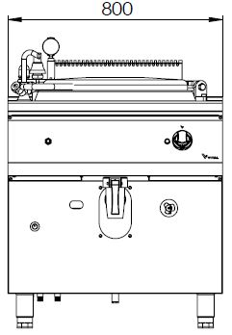
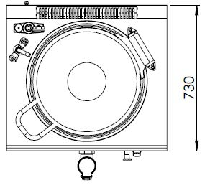
A

B

GKT7080, GKT90100, GKT90150
GKT7080
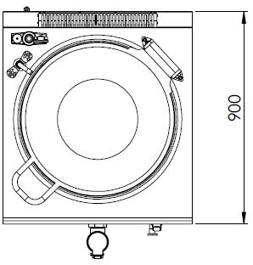
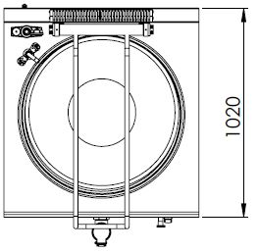

B
B

GKT90250
GKT90100, GKT90150
A
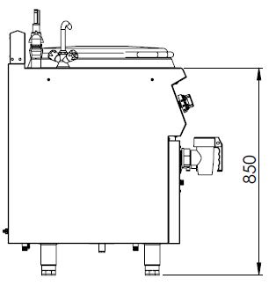
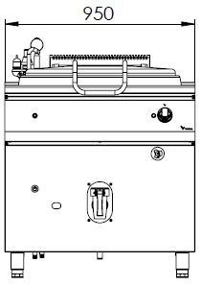

C

GKT7080, GKT90100, GKT90150
GKT90250

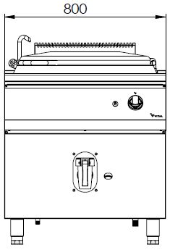
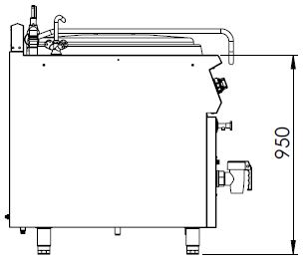
A

C

GKTD90150
GKT90250

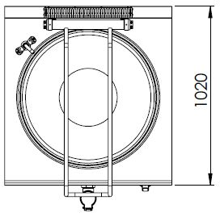
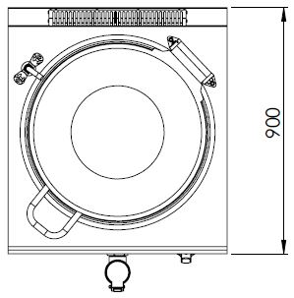

B
B

GKTD90250
GKTD90150
A
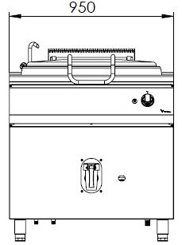
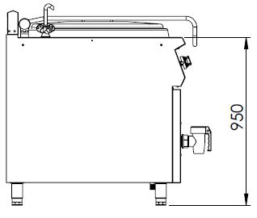

C

GKTD90250
GKTD90250

TRANSPORTATION, PLACEMENT AND READY TO INSTALL
- Do not tilt the device during the transportation, carry it upright.
- Use a suitable vehicle to avoid any kind of damages.
- Do not push or drag the device to bear.
- When transporting by pallet jack or forklift, make sure to not damage the device.
- Carry the device with its packaging until the installation area.
- After placing the device on a flat surface and convenient place, it should be positioned on the balance plaque through its adjustable feet.
- It should be placed under a ventilation system to avoid any kind of bad smell that may occur during cooking process.
- It is recommended to place a suitable sized hood for the ventilation over the device without blocking the outlet of the chimney.
- In case the device is installed next to a wall, a partition, a kitchen furniture etc., make sure they are made by non flammable material or with a suitable thermal insulation coating with a margin of 10 cm, otherwise with a margin of 30 cm.
- Never place a combustible material on top of the device.
- Make a general cleaning before the first usage. You may use soapy water.
- The operating environment and the ventilation system of the device must be between 10°C to 40°C and have a maximum humidity level of %80.
- The device must be installed in accordance within the instructions.
- The protective film on the surface of the device must be stripped off carefully.
- Convenient electrical connection with the required technical specifications must be installed in the area of the device.

GAS CONNECTION
- Convenient gas fittings must be done as written on the product tag.
- Gas pressure corresponding to the gas type as stated on the technical specifications, should be adjusted using the appropriate regulator capacity.
- An appropriate EN 331 Standard valve must be used before the gas inlet of the device.
- The gas connection must be done according to EN 14800 Standards, with a maximum length of 120 cm metal hose.
- Check on the possible gas leackage at the end of the transition.
- Check the gas leackage with a foamy water or a gas leack detector. In case of leackage (foaming will occur on the foamy part or the gas leack detector will give a warning signal), do not use fire, and consult your seller.
- If the device is connected to a gas installation, the inlet of the gas should be designed to not reduce the gaseous flow rate.
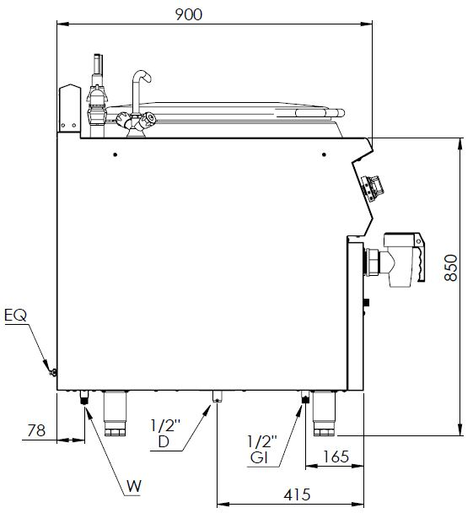
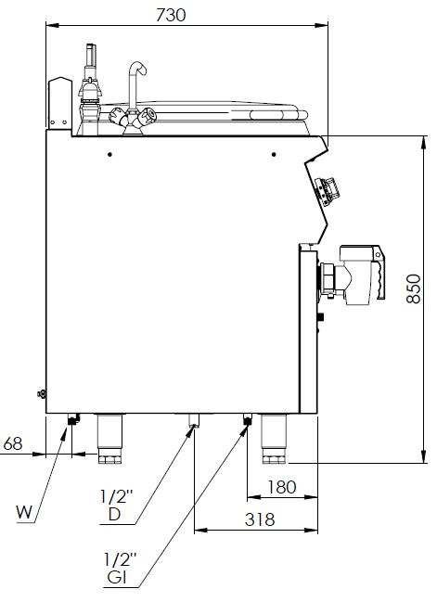

GKT90100, GKT90150
GKT7080

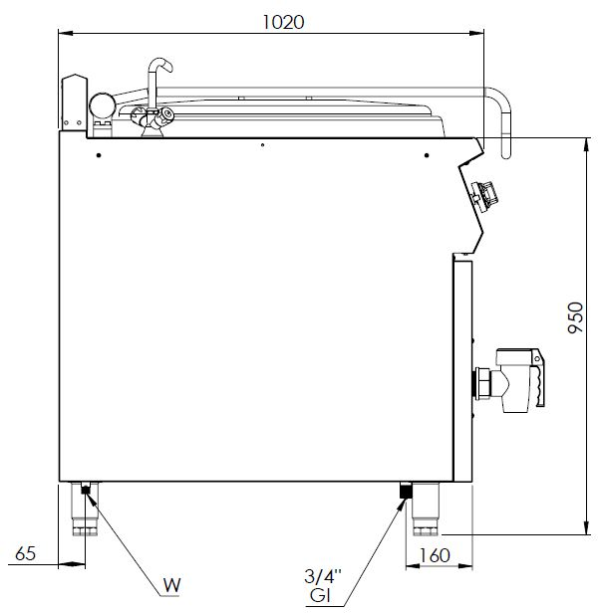
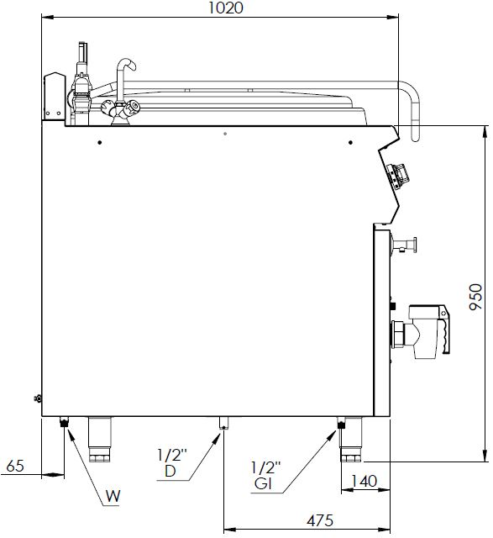

GKTD90250
GKT90250
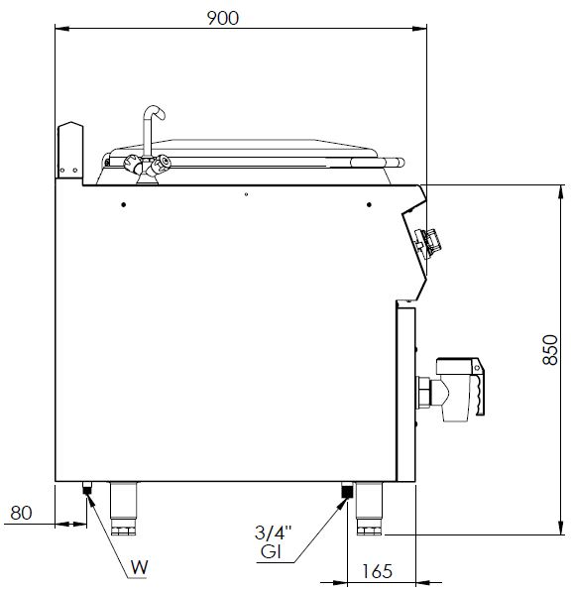

GKTD90150
G= GAS INLET

WATER CONNECTION
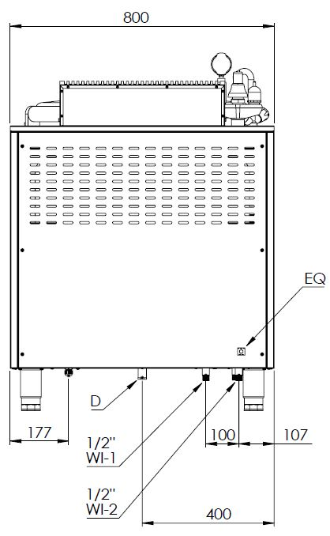
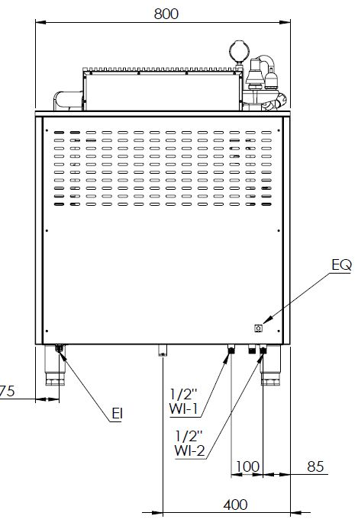

GKT90100, GKT90150
GKT7080
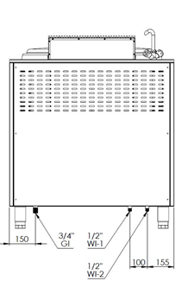
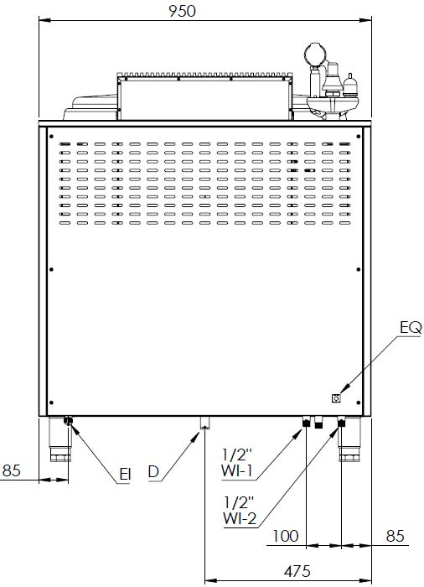

GKTD90150, GKTD90250
GKT90250
WI-1= COLD WATER INLET
WI-2= HOT WATER INLET

USAGE
- The device is designed for professional usage and should only be used by trained personnel.
- Before filling the pan with water, make sure that the drain valve is closed.
- Do not use the device over the capacity specified on the technical specification part.
- Never turn on the device when the tank is empty.

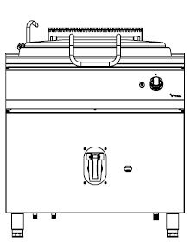
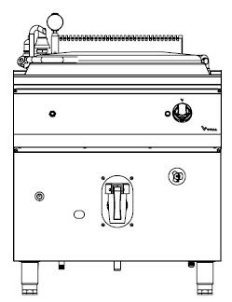
3
2
D
E
B
C
F
1
4
H
A

GKTD90150, GKTD90250

GKT7080, GKT90100 GKT90150, GKT90250

Image -1 CONTROL PANNEL
A | Peephole
B | Thermostat Button
C | Ignition Button
D | Thermostat Lamp
E | Paries Filling Button
F | Level Faucet
H | Water Drain Valve
1 | Peephole
2 | Gas Control Knob
3 | Ignition Button
4 | Water Drain Valve

Ignition Position
Maximum Flame Position
Low Flame Position
Off Position of the Knob

1-) Switching On

INDIRECT GAS BOILING PAN SERIE
- Turn on the gas valve linked to the device.
- Turn on the water valve connected to the device.
- When the level tap is opened, start to fill the paries with the water filling button. When the water starts to flow from the level tap, turn off the valve. Check the water in the paries with the level tap before each operation. Never operate the device when there is not enough water inside the pan.
- Turn on the water filling valve to fill the pan.
- After filling the device with water, switch on the ignition button the ignite.
- The pilot burner will ignite. You may check the burner’s permanent ignition through the peephole.
- If the pilot burner ignites permanently, turn the thermostat knob to the required temperature. (The adjusted temperature is not the value of the water inside the pan but the value of the paries around the pan. That is why there will be some differences with the internal temperature.)

DIRECT GAS BOILING PAN SERIE
- Turn on the gas valve linked to the device.
- Turn on the water valve connected to the device.
- Turn on the water filling valve to fill the pan.
- Lightly press the gas control knob and turn it to counterclockwise to the ignition position.
- When the gas control knob is on the ignition position, press and hold it at the same time of pressing the ignition button several times (until the pilot burner ignites) and check the ignition through the peephole.
- When the pilot burner ignites, stop holding the ignition button and press and hold the gas control knob for 10 seconds. Then, the pilot burner will continue to ignite permanently.
- If the pilot burner continues the ignition, turn the gas control knob counter clock wise to the maximum flame level. For a lower flame, turn the knob to the minimum flame level.

2-) Switching Off
- In the indirect (GBP) serie, turn the thermostat button to the (0) position to turn off the device.
- In the direct (GBPD) serie, turn the gas control knob to the off position to turn off the device.
- After the operation, turn off the gas valve to prevenet any possible gas leakage.

CLEANING
- Do not wash the device with high pressure water.
- Disconnect the device from the gas before cleaning.
- After each operation, clean the device with a cloth dipped in warm soapy water.
- Do not use abrasive detergent or wire brushes when cleaning the device’s surface.

maıntenance and malfunctıon
- The maintenance and the malfunction of the device must be carried out by authorized personnel or by a personnel assigned by the manufacturer.
- All connections and repairs must be carried out by the authorized service centers, otherwise, your device will be out of warranty.

Problems and Solutions
PROBLEM | SOLUTION
The device does not ignite the burners. | Turn on the gas valve of the local gas network or the LPG gas tube.
Burners have low ignition. | Check the compatibility of your device’s gas type and pressure indicated on the product tag with the supplied gas type. If they are not compatible, please contact the AUTHORIZED SERVICE.
The ignition of the burners is not permanent. | There is a problem with the flame arrester fitting. Please contact the AUTHORIZED SERVICE.
The ignition of the burner is not permanent on low level flame. | The low ignition level of the burner is not adjusted. Please contact the AUTHORIZED SERVICE.
A gas smell around the device is detected or the leack detectors are giving warning signals. | Turn off the gas valve and IMMEDIATELY contact the AUTHORIZED SERVICE.

WARRANTY CONDITIONS
- According to the consumer rights law and commercial law of the Ministry of Industry, except in a special case of agreement, sold industrial products by our company has one (1) year of warranty and that period starts from the delivery date of the product.
- The warranty includes all the components of the device against fabrication or faulty workmanship, eliminations of the problems or malfunctions of the device caused by the workmanship and installation errors, replacement of non-repairable parts or the mending of repaired parts that can be reused. It also includes repairings or changes of the components by the authorized personnel, or the labor fee due to the problem under the warranty.
- In order for the warranty conditions to be valid, the maintenance of the components fixed to the device, the maintenance of the product, as indicated in the user’s manual, should be done yearly and montly and the information form must be held after the maintenance to be presented when required.
- The document of the replacement of the component has to be presented for parts warranty claims.
- In order to continue the warranty period, the paid periodic maintenance has to be done by the authorized service and the information form must be held to be presented when required.
- In case of any malfunctions under the warranty period, the time spent in the repairment of the device is added to the warranty period. The repair can be maximum 30 (thirty) days. This period starts when the device is on the service station. In case of the absence of this station, the period will start when the manufacturer or the importer is notified by the product seller.
- In accordance with the regulations of the warranty document implementation fundamentals published by the Ministry of Industry, the warranty deed of the industrial products are the purchase invoices.
- If there is any kind of malfunctions due to both the materail and the workmanship, or assembly faults under the warranty period, the necessary replacement and reparing will be done by our authorized personnel without any charge.

Out of Warranty Cases
- If the product is used above its intended purpose, standards or capacity specified by the manufacturer,
- In case of the bad locationing of the product, continuous usage and unhealthy environment (ex: required ventilation), not suitable floor or flat platform, lack of convenient gas pressure,
- If the product hasn’t been used as explained in the instruction manual,
- If the fault is caused by inconvenient, worng or careless usage,
- If the special tools and equipments installed or the maintenance and repair are made by any other person than the authorized person,
- When requesting a service, if the installation-start documents or purchase invoices of the product are not presented,
- If the informations on the documents of the installation, start or maintenance has been destroyed or changed,
- If the paid annual or the contractual periodic maintenance of the product has not been done on time by the authorized personnel,
- If unoriginal spare parts have been used,
- Notifications to our authorized services under the warranty period about the malfunctions that could not have been repaired, will make the time-out of the warranty stop only for that specific malfunction. In this case, the authorized service will inform about the compensation or the non-troubleshooting and the expanded warranty period will end in 3 months in any cases,
- Parts that may have possible abrasion in time such as mouldings, gas burners, lids, adjustmen knobs, flame holder thermocouples etc. will be repaired or changed with a fee.
- Damages caused by the unnecessary loss of time, the maleficience, the revenue loss, or the conduction of the product from the defective location to another,
- Malfunctions of the product due to squalidity are not covered by the warranty,
- The methods to be followed about the fault detection and elimination are determied completely by MUTAŞ’s technical service management and the service matter is taken as basis for the determination of the malfunction.

AUTHORIZED SERVICE START UP PAGE

Start Up Page
- The model and serial number of your device are shown on the “Technical Data” label affixed to the device.
- Select the technical data according to the device model on the nameplate.

MUST BE FILLED BY AUTHORIZED SERVICE!

COMPANY INFORMATIONS | :
PRODUCT | :
MODEL | :
SERIAL NUMBER | :
PRODUCTION DATE | :
SERVICE STAMP AND SIGNATURE | :
PERSONNEL OF THE SERVICE | :
CONTACT
TEL | : 0312 837 76 72
FAX | : 0312 837 73 38
E-MAIL | : teknikservis@vitalmutfak.com

CONTACT

MUTAŞ MUTFAK ISITMA SİSTEMLERİ SAN. PAZ. İNŞ. TUR. İÇ VE DIŞ TİC.LTD.ŞTİ
HEADQUARTER
ADRES: Plevne Cad. No:40 Gülveren / ANKARA

TEL: (0312) 363 99 33 FAX: (0312) 363 94 92

Web: www.vitalmutfak.com E-Mail:info@vitalmutfak.com
MUTAŞ MUTFAK ISITMA SİSTEMLERİ SAN. PAZ. İNŞ. TUR. İÇ VE DIŞ TİC.LTD.ŞTİ
FACTORY
ADRES: Taşpınar Mahallesi Küme Evleri No:154/A Çubuk / ANKARA

TEL: (0312) 837 76 72 FAX: (0312) 837 73 38

Web: www.vitalmutfak.com
E-Mail:teknikservis@vitalmutfak.com

AFTER SALES SERVICE
For the nearest MUTAŞ/VİTAL Authorized Service, please contact the numbers above.
teknikservis@vitalmutfak.com

